**What Can Danesholme Academy offer children with Special Needs?**

* A commitment to helping every child make progress and be happy at school.
* A wide range of interventions to help children to make progress and to overcome the barriers

of their learning.

* Adaptions in the classroom that

help children to learn

in whatever way suits them.

* Referral to agencies who can help

and support children with SEND, such as Speech and Language Therapists or Specialist Teaching Service.

* Regular reviews between parents , teacher and SENDCo to discuss the children’s needs and progress,



**Interim Inclusion Leader/SENCO:**

Mrs Reynolds

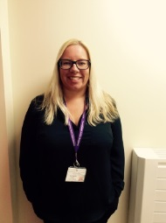

Visit the SEN page on our website for more information about special needs at Danesholme:

[Danesholme Infant Academy - Special Educational Needs and Disabilities](http://www.danesholmeinfantacademy.org/page/?title=Special+Educational+Needs+and+Disabilities&pid=38)





Special

Educational

Needs

Information for parents



At Danesholme we are committed to helping every child to make progress, develop friendships and life skills to be happy at school.

Some children need special help to achieve these things. This leaflet explains what happens if a child has special educational needs.

|  |
| --- |
| One of the Greenwood Dale Foundation Trust Group of Academies |

**What are Special Educational Needs?**

Some children have difficulties that mean they don’t learn in the same way or at the same rate as other children. For example, they have a speech difficulty that makes it hard for them to be understood or problems with learning letters and sounds (phonics) that make learning to read difficult.

These children need special support to help them to learn and to achieve the very best they can.

They may need this support for a short time or for a longer period, but during this time they will be part of our Special Educational Needs (SEN) Register and we will keep a close eye on their progress, look carefully at what special support they need and keep in close touch with their parents.

**What happens if my child has Special Needs?**

If a child is thought to have special needs, this will be discussed with parents and the child may be placed on the SEN Register. This is a list the school keeps of children who need to be closely monitored and who may need additional help.

Very few children with SEND need one-to-one help in school. Most of them can make progress in class with teachers who are aware of their difficulties and know how to adapt their teaching to suit them.

Many (but not all) children on the SEND Register will have some small group time each week to help them with their particular difficulty (phonics or a reading group).



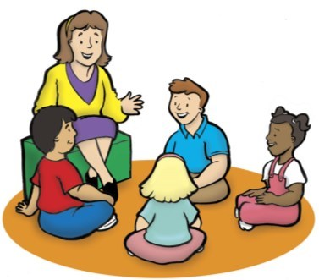

**\*Changes\***

The law on Special Needs changed in September 2014. Key changes affecting parents include:

* Statements have been replaced with **Education, Health & Care Plans** (EHCs). Parents can have a bigger role in the EHC process than they did with statements.
* School Action and School Action Plus have been replaced with a single category of **SEN support.**
* Parents of children on the SEN Register must be given opportunities to meet with the teacher and/or SENDCO to discuss their child’s progress at least three times a year.

**The SENDCo (special Educational Needs & Disability Co-ordinator) Dawn Reynolds.**

Mrs Reynolds is always happy to discuss concerns with parents. You can arrange to see her by ringing the school office or by sending an email via the school website.

Your child’s class teacher.

They will be able to listen to your concerns and discuss with you how your child is managing at school. They may discuss your concerns with the SENDCo.

Who do I talk to if I think my child has Special Needs?